Bahria University,

Karachi Campus



LAB EXPERIMENT NO.

13

LIST OF TASKS

|  |  |
| --- | --- |
| TASK NO | OBJECTIVE |
| 1 | **Write a Python program to implement the Loan Approval Prediction on the above-given scenario with the help of any best-suited classification algorithm** |
| 2 | **Using Knime implement the above-given scenario to predict the loan approval** |

**Task 1: Write a Python program to implement the Loan Approval Prediction on the above-given scenario with the help of any best-suited classification algorithm.**

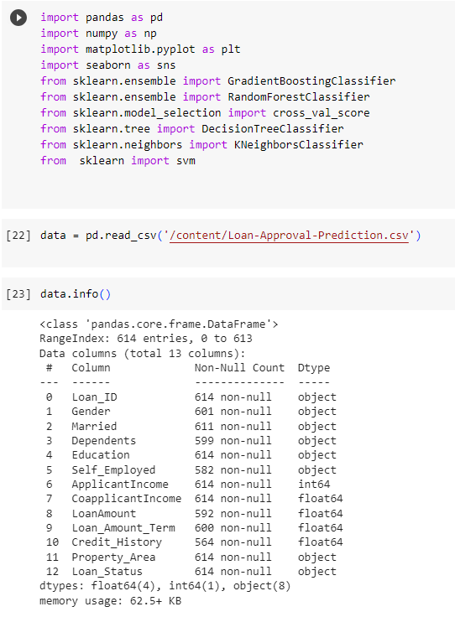Solution:

**Task 2: Using Knime implement the above-given scenario to predict the loan approval.**

